**Application Form**

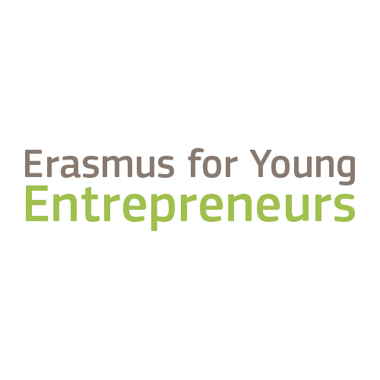

**Erasmus for Young Entrepreneurs (EYE)- Entrepreneur of the Decade Award**

1. **EYE Entrepreneur of the Decade Awards**

The EYE Entrepreneur of the Decade Awards aims to award the most exemplary EYE new entrepreneur (NE) and host entrepreneur (HE) for the past 10 years, with outstanding stories that demonstrate the effect of the programme on their business activities.

To apply for the award, any new/host entrepreneur who has taken part in a completed exchange in the programme in the period 2009-2018 can submit an application for the awards, based on a one-page essay on “Reason(s) why Erasmus for Young Entrepreneurs made me a better entrepreneur”. The application form needs to be sent in electronic format (PDF) to [eyeawards@erasmus-entrepreneurs.eu](mailto:eyeawards@erasmus-entrepreneurs.eu) **by Thursday, 25 October**.

It will then be assessed by panels consisting of currently active Intermediary Organisations from the Erasmus for Young Entrepreneurs programme, European Commission, the Executive Agency for Small and Medium-Sized Enterprises (EASME) and the EYE Support Office in order to select the 3 NE and 3 HE finalists. All finalists will be invited to attend the EYE Entrepreneur of the Decade Awards event in in Brussels in March 2019, where they will need to pitch in 5mins their story to the audience who will, in turn, vote for the winners: the best new and the best host entrepreneur.

Note that only finalists will be contacted with further information on their applications (approx. timing for selection of finalists: December 2018-January 2019).

**Eligibility:**

* The applicant must have taken part in a successful exchange in the Erasmus for Young Entrepreneurs programme that has ended by the submission deadline.
* The applicant must demonstrate the impact of the programme on his/her business. This means that if the applicant was an aspiring entrepreneur when he/she participated in the programme, he/she must have now started a business (even if in initial stages).
* The application and the pitch by the finalist must be done in English, therefore applicants must be fluent in the language.

**Tips to get your application noticed:**

A strong, well-written nomination is powerful and compelling to readers. Consider these points when completing the nomination form:

* Be concise: 1 page maximum! Longer contributions will be disqualified.
* Tell your story and make it attractive: Your story should be vivid and engaging. Think what makes your story different from others and make it stand out.
* Demonstrate results: To be EYE Entrepreneur of the Decade, you need to show the impact of the programme on your business and to demonstrate the achievements for your business thanks to it.
* Polish and edit: Write it. Take a break. Then go back and read it with fresh eyes, changing what you need to make it shine. All finalists will have to pitch their stories in English to the participants (predominantly Intermediary Organisations) at the Award ceremony, so it is important that your story is well written and that you can present it in a fluent and coherent manner at the awards event as well.

1. **Application**

**General information**

|  |  |
| --- | --- |
| Name of entrepreneur: |  |
| Name of company and website: |  |
| Country (and city): |  |
| Host or New Entrepreneur? | Host Entrepreneur New Entrepreneur |
| Contact details (email and telephone): |  |
| Intermediary Organisation (the EYE contact point that you were registered with): |  |
| Relationship number: |  |
| Dates of exchange: |  |
| Please provide a brief description (a couple of lines) of your business: |  |
| Do you agree to be contacted in the future for opportunities to feature your story in publications, audio-visual materials, EYE programme website and social media? | Yes No |

**Specific Privacy statement for the Erasmus for Young Entrepreneurs Entrepreneur of the Decade Awards**

**Your personal data** are processed in accordance with Regulation (EC) No 45/2001[1]on the protection of individuals with regard to the processing of personal data by the Community institutions and bodies and on the free movement of such data.

**The data controller** of the processing operation is Head of Unit COSME.A1, Executive Agency for Small and Medium-sized Enterprises (EASME).

**The legal basis** for the processing operations are Article 5(a) of Regulation EC 45/2001 whereby processing is necessary for the performance of a task carried out in the public interest on the basis of the Treaties or other legal instruments adopted on the basis thereof [2] [3]; Article 5(d) of Regulation EC 45/2001 based on your consent for the following personal data: film/pictures taken during the event.

**The purpose** of this processing operation is to:

 - Receive your application for the Erasmus for Young Entrepreneurs- Entrepreneur of the Decade Award;

 - Assess and verify your application;

 - Contact you with regards to the Awards, additional necessary information, as well as promotional opportunities for your story in publications, audio-visual materials, EYE programme website and social media.

**The following personal data are collected:**

 - Name of entrepreneur

- Country and City

- Contact details (email and telephone)

The recipients of your data will be the Erasmus for Young Entrepreneurs Support Office (c/o EUROCHAMBRES), EASME and European Commission (DG GROW) staff in charge of Erasmus for Young Entrepreneurs programme, as well as Intermediary Organisations participating in the Evaluation Panel.

Your application will be kept for a maximum period of 12 months after the end of the event, unless you have provided your consent to be contacted in the future for your story to be featured in publications, audio-visual materials, EYE programme website and social media.

**You have the right** to access your personal data and the right to correct or delete any inaccurate or incomplete personal data. If you have any queries concerning the processing of your personal data, you may address them to Head of Unit COSME.A1, Executive Agency for Small and Medium-sized Enterprises (EASME) (entity acting as data controller) at the following email: EASME-COSME-COMMUNICATIONS@ec.europa.eu

**You shall have right** of recourse at any time to the EASME DPO at EASME-DPO@ec.europa.eu and to the European Data Protection Supervisor at <https://edps.europa.eu>.

I hereby acknowledge the above information on the protection of personal data: Yes

**Reason(s) why Erasmus for Young Entrepreneurs made me a better entrepreneur**

Provide a brief outline of how your participation in EYE has made you a better entrepreneur and has helped your business already. Focus on impact and achievements but also outline how the benefits of the programme will help you in the long run.

|  |
| --- |
|  |

1. Regulation (EC) No 45/2001 of the European Parliament and of the Council of 18 December 2000 on the protection of individuals with regard to the processing of personal data by the Community institutions and bodies and on the free movement of such data (Official Journal of the European Union L 8, 12.01.2001, p. 1.), currently under revision.
2. EASME establishment act: “EASME was set up by Commission Implementing Decision 2013/771/EU of 17 December 2013 establishing the Executive Agency for Small and Medium-sized Enterprises and repealing Decisions 2004/20/EC and 2007/372/EC (Official Journal of the European Union L 341/73 of 18.12.2013)
3. COSME Regulation: Regulation (EU) No 1287/2013 of 11 December 2013 (Official Journal of the European Union L 347/33 of 20.12.2013).